Prompt engineering Assignment:

Prompt 1:

Education sector:
I am a second-year engineering student, and I need to conduct a 15–20 minute seminar on the topic “Development of Artificial Intelligence.”
Please explain it in simple and clear language so that I can easily understand and present it confidently.
Structure the content in this format:
Introduction (what AI is and why it is important)
History and evolution of AI (major milestones)
Key developments and technologies (Machine Learning, Deep Learning, etc.)
Real-world applications
Current trends and future of AI
Advantages and challenges
Conclusion
constrains:
Make it presentation-friendly
Give simple real-life examples
Suggest 1–2 questions I can ask the audience
Provide a short conclusion I can memorize
Keep it easy to explain and not too technical.

Result 1:
Here is a structured, presentation-friendly guide for your seminar on the "Development of Artificial Intelligence."
Since you are a second-year engineering student, I have balanced technical accuracy with simple explanations so you can speak confidently without getting stuck on complex jargon.

Seminar Topic: The Development of Artificial Intelligence
Time: 15–20 Minutes
Goal: To explain how AI evolved from a concept to a tool that shapes our daily lives.

1. Introduction (2–3 Minutes)
What is AI?
Start by defining AI simply. It is not just robots taking over the world; it is a branch of computer science dedicated to creating systems capable of performing tasks that typically require human intelligence.
- Core Definition: AI is the simulation of human intelligence processes by machines, especially computer systems.
- Key Capabilities: Learning (acquiring information), Reasoning (using rules to reach conclusions), and Self-Correction.
Why is it Important?
AI is the "new electricity." Just as electricity transformed every industry 100 years ago, AI is now transforming healthcare, transportation, and communication. It allows us to process data faster than any human ever could.
Speaker Tip: “Think of a calculator. It can do math faster than us, but it’s not 'smart.' AI is different because it can learn from its mistakes.”

2. History and Evolution (3–4 Minutes)
Break the history down into these easily digestible eras.
- The Birth (1950s):
  - Alan Turing: Often called the father of AI. He proposed the "Turing Test"—if a machine can converse with a human without the human realizing it's a machine, it is intelligent.
- The Early Excitement (1950s–1970s):
  - Researchers created programs that could play checkers and solve simple algebra problems.
  - Example: ELIZA (1966), a very simple chatbot that acted like a therapist.
- The AI Winter (1970s–1980s):
  - Funding dried up because AI didn't live up to the hype. Computers weren't fast enough, and storage was too expensive.
- The Boom (1990s–Present):
  - 1997: IBM’s Deep Blue defeated world chess champion Garry Kasparov. This proved machines could "out-think" humans in specific logic tasks.
  - 2010s: The explosion of "Big Data" and powerful GPUs (graphics cards) allowed AI to truly learn.

3. Key Developments & Technologies (4–5 Minutes)
This is the technical core of your presentation. Explain these three concentric circles.
- Artificial Intelligence (The Umbrella): The broad concept of smart machines.
- Machine Learning (The Subset):
  - Instead of writing code for every single rule (e.g., "if it has whiskers, it's a cat"), we feed the computer thousands of photos of cats and let it figure out the patterns itself.
- Deep Learning (The Breakthrough):
  - This is inspired by the human brain. It uses Artificial Neural Networks.
  - Imagine layers of "neurons." One layer recognizes edges, the next shapes, and the final one recognizes a face. This is the technology behind self-driving cars and FaceID.
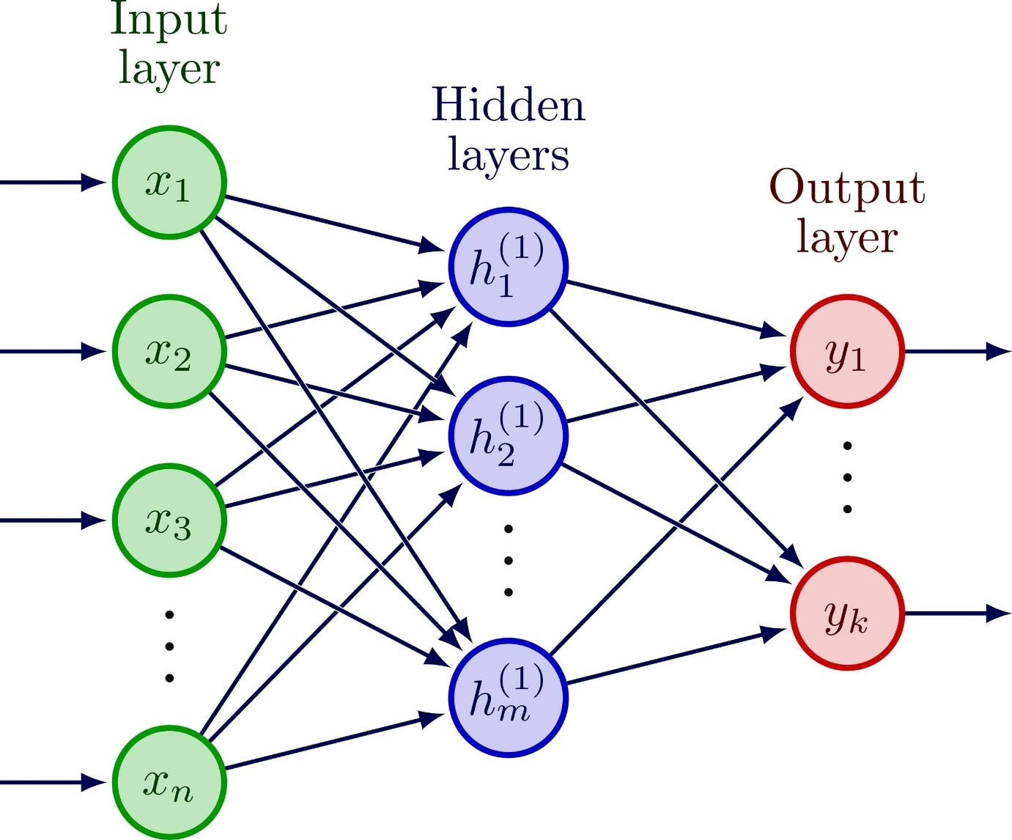
Shutterstock
Explore

4. Real-World Applications (3–4 Minutes)
Give examples your classmates will recognize immediately.
- Healthcare: AI can detect tumors in X-rays faster and sometimes more accurately than doctors.
- Social Media: The algorithm that decides what Reels or TikToks you see next is a powerful AI analyzing your behavior.
- Transportation: Self-driving cars (Tesla, Waymo) use computer vision to "see" the road.
- E-Commerce: When Amazon says, "Customers who bought this also bought...", that is a Recommendation Engine.

5. Current Trends & Future (2–3 Minutes)
- Generative AI (GenAI): This is the current trend (like ChatGPT and Gemini). AI is no longer just analyzing old data; it is creating new text, images, and code.
- Multimodal AI: Systems that can understand text, audio, video, and images all at the same time.
- Ethical AI: The future isn't just about making AI smarter, but making it fair—ensuring it doesn't have biases against certain groups of people.

6. Advantages & Challenges (2 Minutes)
Advantages:
- 24/7 Availability: AI never gets tired or needs a coffee break.
- Speed: Can process millions of documents in seconds.
- Safety: AI robots can do dangerous jobs (like bomb disposal or mining).
Challenges:
- Job Displacement: Fear that automation will replace human workers.
- Data Privacy: AI needs huge amounts of data—often our personal data.
- Lack of Creativity: AI can mimic art, but it cannot truly "feel" emotion or inspiration yet.

7. Conclusion (1 Minute)
Summarize your talk.
"To wrap up, the development of AI has moved from simple logic games to systems that can diagnose diseases and drive cars. It is the most powerful tool engineering has ever created. However, it is just that—a tool. The future depends not on what AI can do, but on how we choose to use it."

Presentation Toolkit
🎤 2 Questions to Ask the Audience:
(Ask these to make your seminar interactive)
- "How many of you used an AI tool (like ChatGPT or Google Lens) today? Raise your hands." (Shows prevalence).
- "Do you think an AI will ever be able to write a better love letter than a human? Why or why not?" (Fun, engages opinion).
🧠 Short Conclusion to Memorize:
"AI is no longer science fiction; it is our reality. As engineers, our job isn't just to build these systems, but to ensure they solve real problems for real people. Thank you."

Prompt 2:

Education sector:
I am a second-year engineering student, and I need to write an assignment on the topic “Development of Artificial Intelligence.”
Please write the assignment in simple and clear language that is easy to understand. Avoid very complex technical terms.
Structure the assignment in the following format:
- Introduction – What Artificial Intelligence is and why it is important
- History and Evolution of AI – Major milestones and key developments
- Important Technologies – Machine Learning, Deep Learning, Neural Networks, etc.
- Applications of AI – Real-world examples in healthcare, education, business, etc.
- Advantages and Challenges of AI
- Current Trends and Future Scope of AI
- Conclusion – A short and meaningful summary
constraint:
The assignment should be around 4–6 pages
Use simple explanations with examples
Maintain formal academic tone
Add headings and subheadings
Provide a short conclusion paragraph that is easy to remember
Make the content suitable for college submission.

Result 2:
I am a second-year engineering student, and I need to write an assignment on the topic “Development of Artificial Intelligence.”
Please write the assignment in simple and clear language that is easy to understand. Avoid very complex technical terms.
Structure the assignment in the following format:
- Introduction – What Artificial Intelligence is and why it is important
- History and Evolution of AI – Major milestones and key developments
- Important Technologies – Machine Learning, Deep Learning, Neural Networks, etc.
- Applications of AI – Real-world examples in healthcare, education, business, etc.
- Advantages and Challenges of AI
- Current Trends and Future Scope of AI
- Conclusion – A short and meaningful summary
Additional requirements:
- The assignment should be around 4–6 pages
- Use simple explanations with examples
- Maintain formal academic tone
- Add headings and subheadings
- Provide a short conclusion paragraph that is easy to remember
Make the content suitable for college submission.

Prompt 3:

Health care:
I am a college student with a busy schedule, and I want to improve my overall health.
Please suggest a simple and practical daily routine that includes:
Diet recommendations (easy and affordable foods)
Basic exercise plan (30–45 minutes)
Sleep schedule
Stress management tips
Keep the suggestions realistic for a student lifestyle.
Avoid very strict or extreme advice.
Explain why each recommendation is important in simple language.

Result 3:
Since you are an engineering student with a busy schedule, your routine needs to be efficient. You don't need expensive gym memberships or fancy "superfoods" to be healthy.
Here is a practical, realistic daily routine designed for a student living in a hostel or at home in India.
1. Diet Recommendations (Simple & Affordable)
Goal: Steady energy for studying without the "afternoon crash."
As a student, you likely rely on mess food or home-cooked meals. The key is to add nutrition to what you already eat, rather than changing everything.
- Breakfast (The Brain Fuel):
  - Eat: Idli, Dosa, or Upma are great, but they are high in carbs. Add protein: 2 boiled eggs or a glass of milk. If you are vegetarian, eat a handful of soaked almonds or peanuts.
  - Why: Carbs give quick energy, but protein keeps you full during long lectures so you don't lose focus by 11 AM.
- Lunch (The Balancing Act):
  - Eat: Rice or Chapati with Dal/Sambar and a vegetable (poriyal/sabzi).
  - Tip: Try to eat a little less rice and a little more vegetables/dal.
  - Why: Too much white rice causes a "sugar spike," which leads to sleepiness in afternoon classes.
- Evening Snack (The Junk Killer):
  - Eat: Instead of samosas or puffs, keep "dorm-friendly" snacks: Roasted chana (chickpeas), peanuts, or a fruit (Banana/Guava).
  - Why: These are cheap, require no cooking, and provide iron and vitamins.
- Dinner (Light & Early):
  - Eat: Chapati or Idli. Avoid heavy, oily fried foods at night.
  - Why: Heavy meals disrupt sleep quality, making you tired the next morning.
- Hydration: Keep a water bottle on your study desk. Dehydration is the #1 cause of "brain fog" and headaches.

2. Basic Exercise Plan (30–45 Minutes)
Goal: Mental clarity and posture correction (since you sit a lot).
You can do this in your room or a nearby park. No equipment needed.
- Warm-up (5 mins): Neck rotations, arm circles, and marching in place.
- The Workout (20–30 mins):
  - Brisk Walking or Jogging: 15 minutes. (Put on headphones and listen to music/podcast).
  - Bodyweight Circuit (2 rounds):
    - 20 Squats: Strengthens legs (good for long sitting hours).
    - 10 Push-ups: Builds upper body strength (do knee push-ups if standard ones are too hard).
    - 30-second Plank: Strengthens your core/back to prevent back pain from studying.
- Cool-down (5 mins): simple stretching. Reach for your toes and hold.
Why this works: Exercise increases blood flow to the brain, which actually helps you solve complex engineering problems faster.

3. Sleep Schedule
Goal: Memory consolidation.
Engineering concepts (like the ones you study in DBMS or Python) are moved from "short-term" to "long-term" memory while you sleep.
- Ideal Window: 11:30 PM – 6:30 AM (7 hours).
- The "No-Screen" Rule: Try to put your phone away 20 minutes before sleeping. The blue light from the screen tricks your brain into thinking it's daytime, making it harder to fall asleep.
- Nap Strategy: If you are exhausted after college, take a "power nap" (20 minutes max) before 5 PM. Anything longer will ruin your night sleep.

4. Stress Management Tips
Goal: Managing exam pressure and assignments.
- The "Two-Minute" Breathing: Before you start a difficult assignment or exam, do this: Inhale for 4 seconds, hold for 4 seconds, exhale for 4 seconds. It instantly lowers your heart rate.
- Plan, Don't Panic: Stress often comes from a pile of undone work. Use a simple to-do list. Break a big project (like a "Hospital Management System") into tiny tasks (e.g., "Just design the login page today").
- Socialize Offline: Spend 10–15 minutes talking to friends or family without looking at your phone. Human connection is a powerful stress reliever.
Summary of the Routine
Time | Activity
Morning | Wake up, hydrate, 30-min exercise, high-protein breakfast.
College | Stay hydrated. Walk around during breaks.
Evening | Healthy snack (chana/fruit). relax for 30 mins.
Night | Light dinner. Study block. Sleep by 11:30 PM.
Would you like a simple weekly grocery list of affordable items to keep in your room for healthy snacking?

Prompt 4:

Health care:
I want to understand the health condition [mention condition like diabetes / anemia / high blood pressure] in simple language.
Please explain:
What it is
Causes
Symptoms
Risk factors
Prevention methods
Basic treatment options
Keep the explanation easy to understand for a non-medical student.
Use simple examples where possible.

Result 4:
Since you didn't specify a condition in the brackets, I will explain Type 2 Diabetes (High Blood Sugar). This is one of the most common health issues today and is heavily influenced by the lifestyle factors (diet, sleep, stress) we just discussed.
Here is a simple, engineering-friendly explanation of Type 2 Diabetes.

1. What is Type 2 Diabetes?
Think of your body like a car engine and food as fuel.
- When you eat, your body turns food into glucose (sugar), which is the fuel your cells need for energy.
- To get that fuel inside the cells, your body needs a hormone called Insulin.
- The "Lock and Key" Analogy:
  - The Cell: A room that needs fuel.
  - ** The Door:** The entry point for sugar.
  - Insulin: The "Key" that opens the door.
In Type 2 Diabetes:
You have the key (Insulin), but the lock is "rusty" or "jammed." The key doesn't turn easily.
- Result: The fuel (sugar) stays in your blood instead of going into the cells. Your cells starve for energy, while your blood becomes thick with sugar.

2. Causes
The primary cause is Insulin Resistance.
This happens when your cells stop responding to insulin properly. Your pancreas (the organ that makes insulin) tries to work overtime to make more keys to force the doors open, but eventually, it gets tired and can't keep up.
Why does the lock get jammed?
- Too much sugar/fat: Overloading the system.
- Inactivity: Exercise helps "oil" the lock, making it work better. If you don't move, the lock gets stiff.
- Visceral Fat: Belly fat releases chemicals that block the lock.

3. Symptoms (Warning Signs)
If your engine isn't getting fuel, you see these signs:
- Frequent Urination: Your body tries to flush out the excess sugar through urine.
- Excessive Thirst: Because you are losing so much water from peeing.
- Extreme Fatigue: Even if you eat, your cells aren't getting energy, so you feel tired (like a car with a full tank but a clogged fuel line).
- Blurry Vision: High sugar levels pull fluid from your eyes' lenses.
- Slow Healing: Cuts or bruises take weeks to heal because thick, sugary blood circulates poorly.
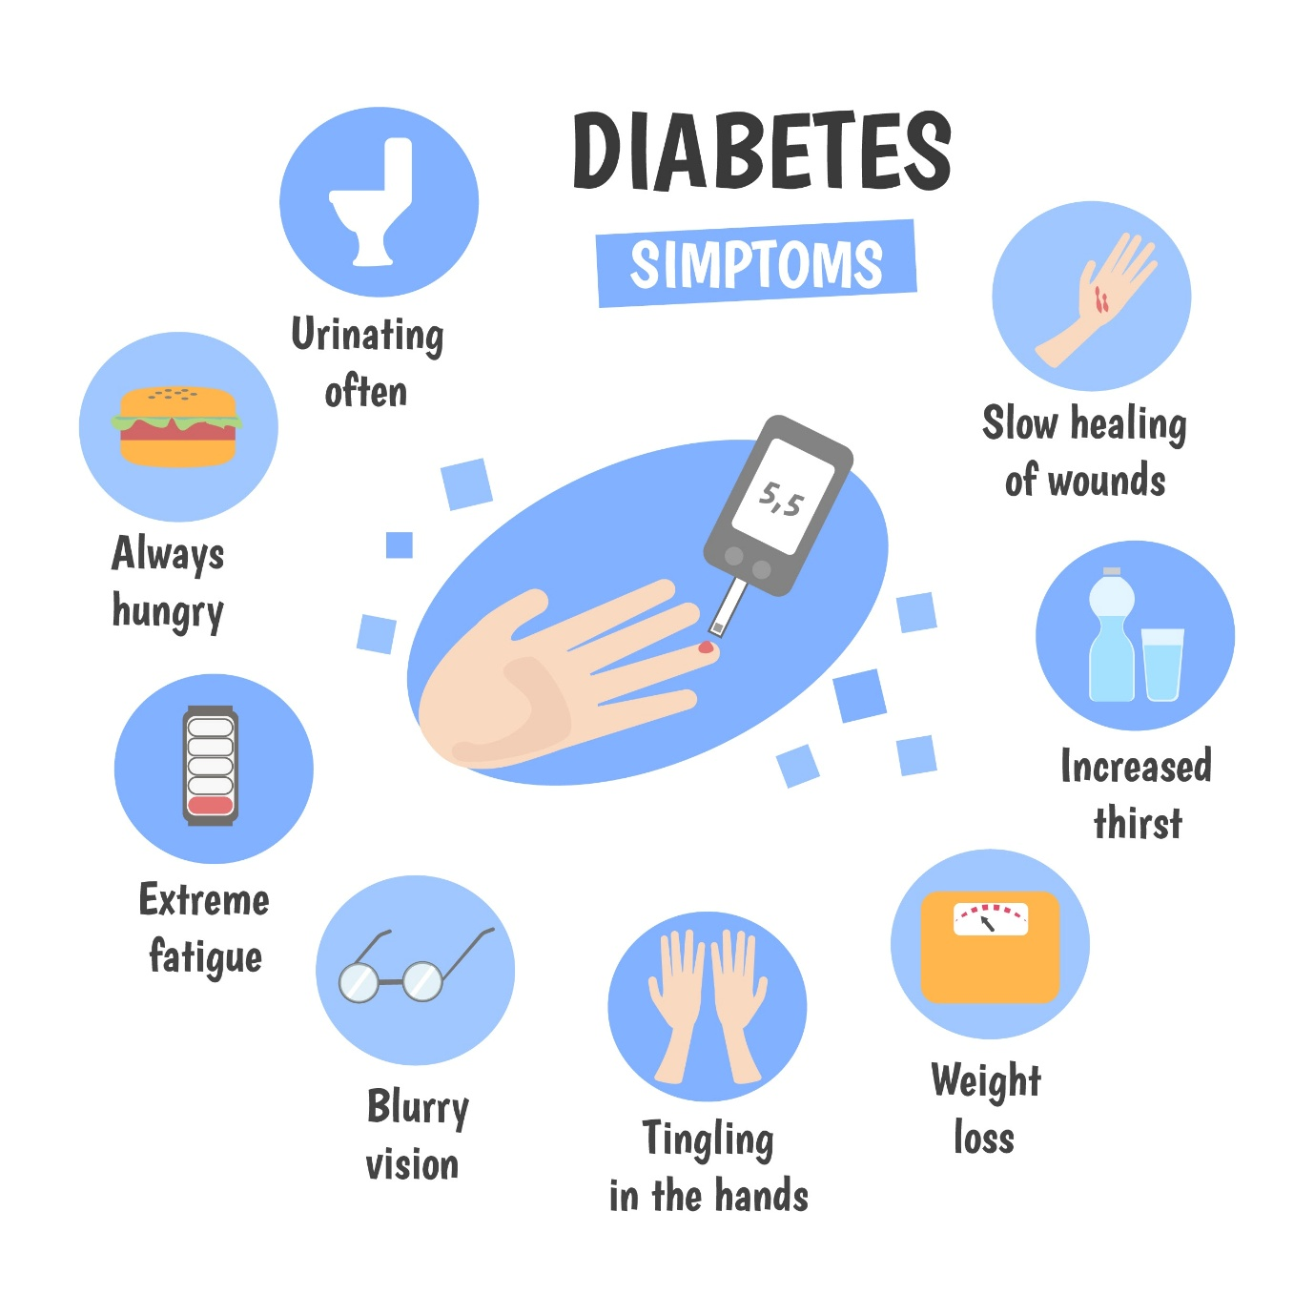
Shutterstock

4. Risk Factors
Who is most likely to get it?
- Family History: If your parents have it, your "locks" might be genetically prone to jamming.
- Weight: Being overweight, especially carrying fat around the belly.
- Age: Risk increases after 45, but now many young people (even students) are getting it due to lifestyle.
- Sedentary Lifestyle: Sitting for long hours (common for engineers/students).

5. Prevention Methods
You can fix the "rusty lock" before it breaks permanently.
- Move More: Walking 30 minutes a day makes your cells more sensitive to insulin (it "oils" the lock).
- Cut the "White" Foods: Reduce white rice, white bread, and sugar. Switch to brown rice, oats, or millets.
- Lose Belly Fat: Even a small weight loss (5-10%) can restore insulin function.

6. Basic Treatment Options
If prevention fails, doctors use:
- Lifestyle Changes: Diet and exercise are always the first "prescription."
- Oral Medication (Metformin): A pill that helps the "key" turn the lock more easily and stops the liver from dumping more sugar into the blood.
- Insulin Therapy: In advanced stages, if the body stops making keys (insulin) entirely, you have to inject them manually.

Would you like me to explain a different condition, like Anemia (low iron/tiredness) or Hypertension (high blood pressure)?

